**Centralized Version Control System**

* Version control (Revision Control) is a system that records changes to a file or groups of files and directories over time, so that we can review or go back to specific versions. In addition to this it will allow multiuser mode
* In Centralized System, anyone who makes changes needs to given access to the central location (Central Repository) 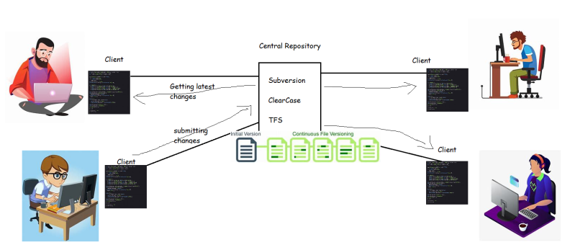
* Once they have the access and the client software, the users can get the working copy, make changes, get latest changes etc.
* For any reason if the central repository is down, all the developers will not be able to
  + make changes in connected centralized version control system
  + update/get changes in the disconnected centralized version control system
* To resolve this, we have version control administrators who configure
  + Primary and Standby Servers
* For any version control system, backups and archival are important, Administrators configure this (Subversion Administrator, ClearCase Administrators)

**Distributed Version Control System**

* Git was created by Linus Torvalds (who is also known for the linux kernel).

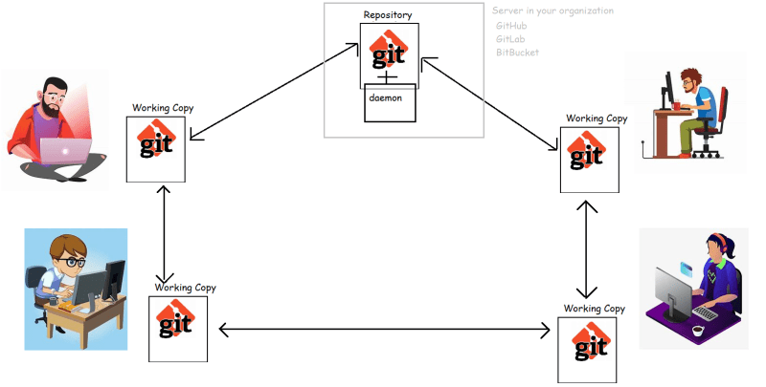

The primary objective behind Git was to implement and design a version control system that is distributed, reliable and fast.

**Working with Git**

Installing Git:

* RedHat: sudo yum install git -y
* Ubuntu: sudo apt install git -y

When any system wants to become master, he needs to have https daemon running.